Short Analyses

March 2024

Mitja Perko

Wage Differences Between the Public and Private Sector and the Wage Premium

Summary

The analysis shows that, as in other countries, the average wage in the public sector in Slovenia is higher than in the private sector. In the period 2005−2022, the average wage in the public sector was about a quarter higher than the average wage in the private sector.

The difference in the average wage between the public and private sector is influenced by differences in the demographic and employment structure of employees, such as differences in educational structure, gender, age, type of contract, professions, etc. The distribution of wage levels differs significantly between the sectors due to these differences. In the private sector, the distribution is much more concentrated at lower wage levels, mainly due to occupations that appear in the private sector but not in the public sector. The distributions are more similar if we only compare occupations that are common to both the public and private sector.

Estimates of wage differences, after eliminating certain demographic-employment differences in the structure of employees between the sectors, show that wages in the public sector are lower in medium and high professional occupational groups (negative public sector wage premium) but higher in occupations with simpler tasks (positive public sector wage premium).

This short analysis is a direct update of the analysis on wage differences between the public and private sector from Economic Issues 2018 (IMAD 2018) and Roter et al. (2017), this time based on detailed administrative microdata of employees.

Wage Differences Between the Public and Private Sector and
the Wage Premium
This analysis addresses key aspects of wage differences between the public and private sector – what is the ratio between average wages in the public and private sector, why is the average wage in the public sector higher than in the private sector, what are the distributions of wages in the sectors, how have they changed over time, and what are the wage differences when comparing occupations and employees with similar characteristics between the public and private sector.

What is the Ratio Between the Average Wage in the Public and Private Sector?
In Slovenia, the average wage in the public sector, as in other countries, is higher than in the private sector. In the period 2005−2022, the average wage in the public sector was about a quarter higher than the average wage in the private sector. The wage ratio has been gradually decreasing over time, except in some years, due to slightly higher growth of the average wage in the private sector. A short-term increase in the ratio occurred in 2008 and 2009 due to high wage growth in the public sector with the introduction of a unified pay system, but this was followed by a period of reduction due to the adopted public finance austerity measures and a significant increase in the minimum wage, which particularly increased the average wage in the private sector. The increase in the ratio in 2020 and 2021 was influenced by a spike in wages in the public sector due to payments of Covid-related bonuses, especially in healthcare. In 2022, the ratio decreased due to the cessation of Covid bonus payments in the public sector, which led to a decrease in the average wage there.
Figure 1: Ratio between the average wage in the public and private sector
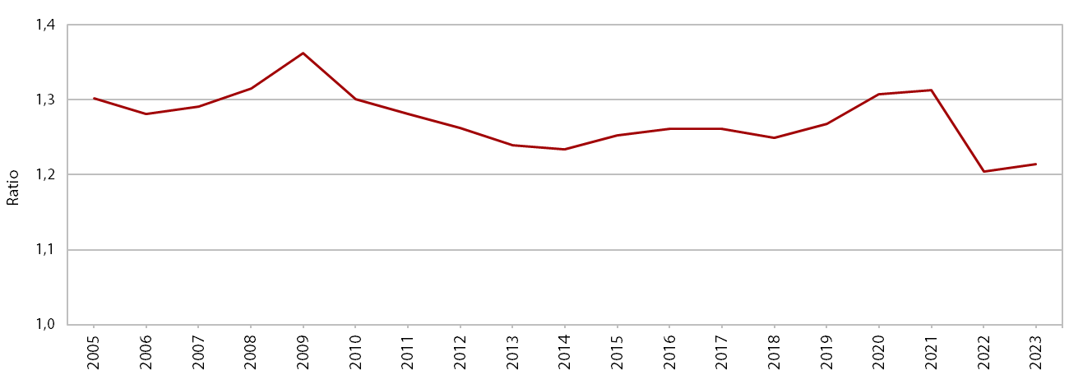
Source: SURS (2024b), IMAD estimates.

Why is the Average Wage in the Public Sector Higher Than in the Private Sector?
The difference in the average wage between the public and private sector is influenced by differences in the demographic and employment structure of employees. The wage differences between the sectors stem from differences in the educational structure of employees, gender, age, length of service, type of contract, professions, etc. A comparison of the sectors according to these characteristics shows that in 2022, about 60% of all employees in the public sector had a higher education, while there were significantly fewer such employees in the private sector. Since higher levels of educational attainment are generally associated with higher earnings, this leads to a higher average wage in the public sector than in the private sector. The public sector also has a higher proportion of older employees. It is typical that wages increase with age, as older employees also have a longer tenure and receive a higher wage with possible seniority bonuses (length of service bonus, seniority-based promotions). The higher average age in the public sector is also related to the occupational structure: occupations that require less demanding skills are more common in the private sector and are often performed by younger people with lower education, while the average age in the public sector is higher than in the private sector. One of the most important factors of wage differences is the structure of occupations, which is a consequence of differences between activities within the sector. In the public sector, the proportion of occupations requiring more specific skills is almost 50 percent, while in the private sector it is much lower. Although the average wage among professional groups for specialists is slightly higher in the private sector, a large proportion of such occupations in the public sector has a greater impact on the average wage of the entire sector than in the private sector.
Figure 2: Share of persons employed in the public and private sector, by selected characteristics (left); level of average gross wage in the public and private sector, by selected characteristics (right), 2022
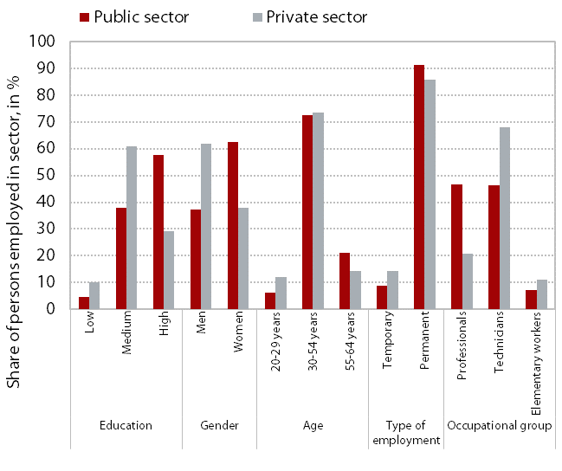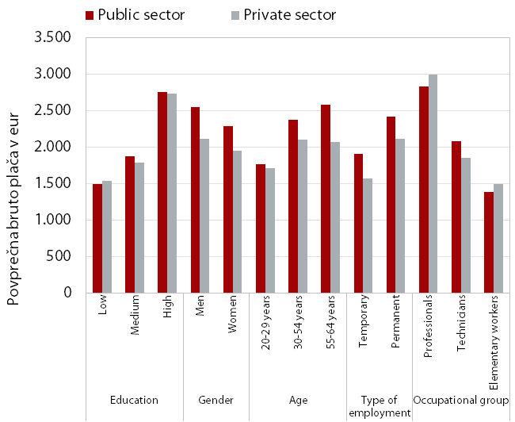
Source: SURS (2024b), IMAD estimates.
Note: Data on the proportion of employees by demographic-employment characteristics and their average wages may differ slightly from the data officially published by SURS. This is influenced by minor differences in the sample of employees used.

What are the Distributions of Wages in the Public and Private Sector? How Have the Distributions Changed Over Time?
The distribution of wage levels differs significantly between the sectors due to differences in employment and occupational structures. The distribution of wages in the private sector is much more concentrated at the lower wage levels due to a higher proportion of employees with lower education, which is almost three times as high as in the public sector. The distribution in the public sector shows greater uniformity. The shift of distributions in both sectors to the right is characteristic of positive wage movements over time. The wage distribution, as is usual for income distributions, is asymmetric to the right. Typically, the average wage is higher than the median wage, i.e. the midpoint at which half of the employees earn less and the other half earn more. In 2022, based on data from the entire sample, about 64% of employees in the private sector received a lower wage than the average wage of this sector, while in the public sector, 56% of employees received a lower wage than the average. However, when we compare occupations that occur in both the public and private sector, the wage distributions between the sectors are much more similar.
Figure 3: Public and private sector wage distribution, all occupations (left); public and private sector wage distribution, only comparable occupations (right) years 2015, 2019 and 2022
(please note: red = public, black = private)
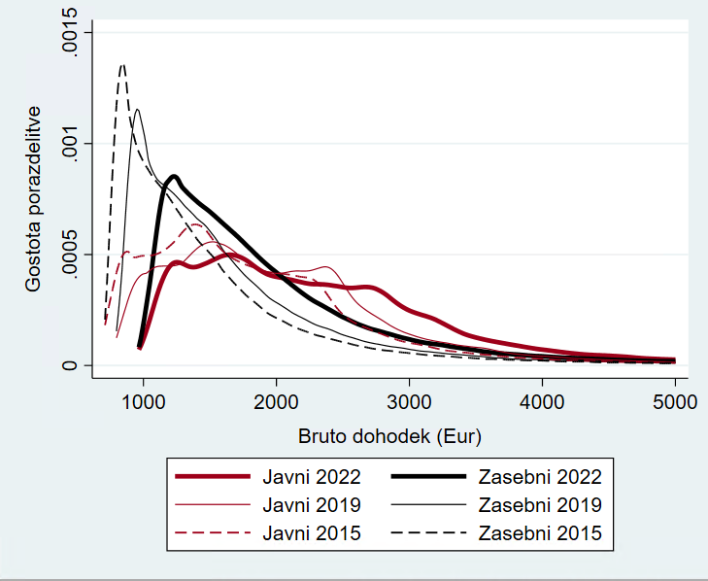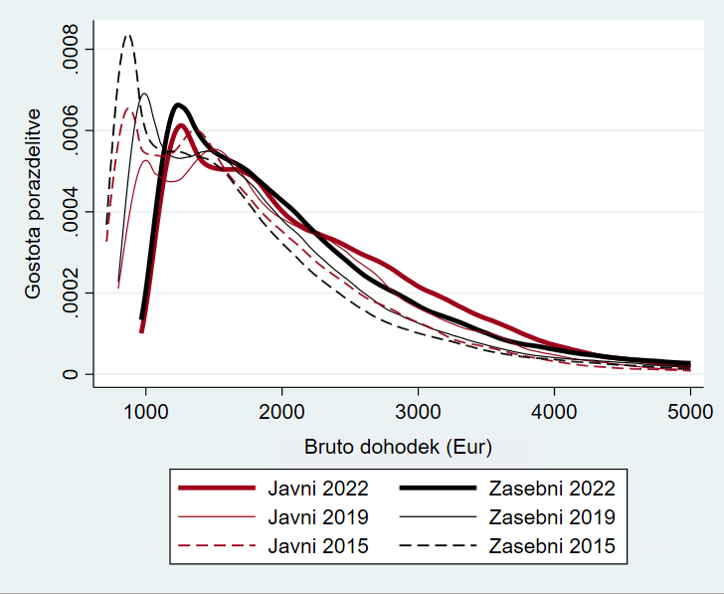
Source: SURS (2024a), IMAD estimates.
Note: The distribution of wages in a given year is cut off at the bottom at 90% of the minimum wage. For the definition of the sample, see also note 2. In the figure on the right, comparable occupations are at the fourth level of detail. In the figure on the right, the wage distribution curve for the public sector rises slightly above the curve for the private sector at wages of EUR 2,500 and above, indicating slightly more frequent wages in this segment of distribution in 2022. Although the distribution for both sectors only includes comparable occupations, this may also be, in our opinion, a result of differences in the education and age structure of employees between the sectors and in the structure of employment types and by gender, which were not removed from the distributions and may affect the shape of the distribution of both sectors. How wages of employees between sectors compare only in comparable occupations and at the same time among employees who have the same education, age, gender, and other characteristics, see section 1.4 on wage premium.

What are the Wage Differences Between the Public and Private Sector When
We Control for the Demographic-Employment Structure Differences?
For a comparison of wages between the public and private sector, it is more appropriate to consider only occupations that are comparable between the sectors and to control for other demographic and employment differences. Each sector includes occupations that do not appear in the other sector or are only present in small numbers. Such occupations include, for example, certain service workers, sales workers, and industrial and construction workers that occur in the private sector, while occupations such as teachers and doctors mainly occur in the public sector. To ensure appropriate comparability of wages between the sectors, we subsequently compare occupations that occur in both sectors. Such occupations include managers, professionals, or technicians from the fields of scientific, engineering, and business studies, office clerks, accounting clerks, occupations for some other services, and for certain simple tasks. The comparison of wages between sectors also needs to exclude employment and demographic characteristics of employees that affect the wage level in a particular occupation and sector. Regression models enable such a comparison.

The difference in average wage between the public and private sector that remains after eliminating the demographic and employment structure can be interpreted as the so-called wage premium. When there is no wage premium, individuals with the same level of education, age, and in comparable occupations receive similar wages in both the public and private sector. However, when individuals with comparable characteristics and in comparable occupations are paid more in one sector than in another, this can be interpreted as a wage premium of that sector. Understanding the wage premium is important for designing an appropriate wage policy. If the premium for the public sector is positive and offers higher wages for similar work as in the private sector, this can lead to employees moving from the private to the public sector and put pressure on public finance expenditures. In the case of a negative wage premium, the public sector may face difficulties in attracting and retaining staff, which can lead to lower quality of public services.

The existence of a wage premium can be influenced by institutional, political, and economic factors. While wage setting in the private sector is driven by the profit motive, the level of wages in the public can also be subject to political motives. The public sector is also under pressure to set an example in terms of wages, especially for less educated employees in the public sector, allowing them to receive higher wages than they would in the private sector. The existence of a negative wage premium in the public sector can be a consequence of non-monetary benefits of the public sector, such as greater job security, as the public sector is characterised by lower employee turnover due to redundancies than the private sector, and more days off. The wage premium can also reflect differences and factors that cannot be taken into account in the evaluation. The models used to evaluate differences in wages include many factors that explain a large part of the aforementioned difference between the average wages of the sectors, but it should be borne in mind that it is not possible to include all factors that would influence differences in wages between individuals. Such factors include an individual's productivity, skills, motivation, work organisation, the shortage of certain staff, and thus the impact on wages, etc. Below we present estimates of the wage premium for the public sector, by selected occupational groups and by wage level.

The estimates of the wage premium for Slovenia show that the premium in the public sector is negative for the medium and high professional occupational groups and positive for the occupations with simpler tasks. Employees with comparable characteristics are paid relatively less in the public sector than in the private sector in occupations such as experts in various fields, technicians, and office clerks, while occupations for simpler tasks are paid relatively more. The magnitude of the negative premium for high and medium-professional occupations is, according to our estimates, on average between 5% and 10%. Meanwhile, the wage premium for some less demanding occupations is positive.

The public sector wage premium is positive at a lower wage level and negative at a higher wage level. The estimates of the premium for different wage levels show that the wage premium varies with the wage level. The positive public sector wage premium decreases (and eventually becomes negative) with increasing wages – moving upwards in the distribution, i.e., at higher quantiles. Based on model estimates, however, we cannot confirm the wage premium with certainty in the middle of the wage distribution.
Figure 4: Wage premiums in selected comparable public and private sector occupations, in %
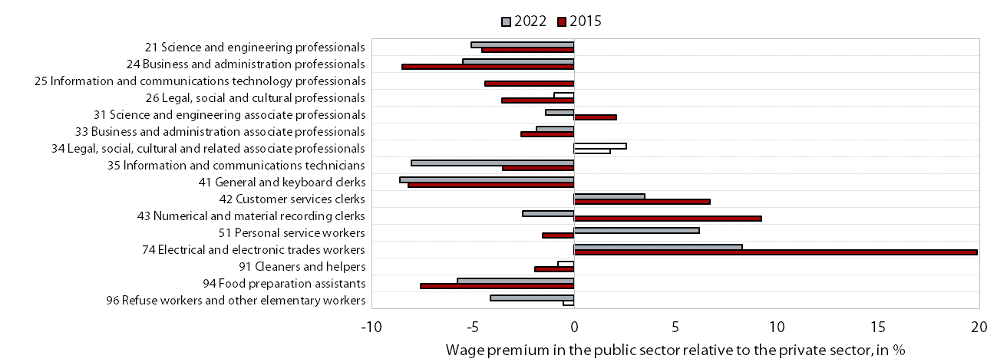
Source: SURS (2024a), IMAD estimates.
Note: Robust standard errors at the individual level were used. Comparable occupations are selected at the 2-digit level. Full columns represent a statistically significant premium at a confidence level of at least a 90%.

Figure 5: Wage premiums in the public sector relative to the private sector by level of gross wage in 2022, in % (please note: y-axis label = coefficient of wage premia)
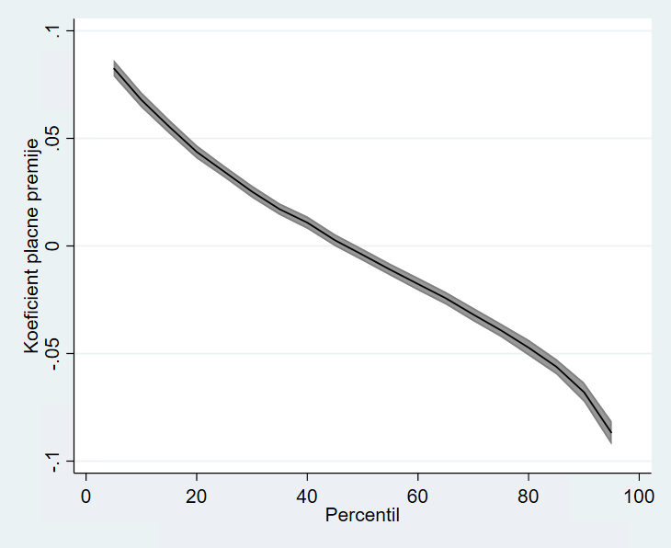
Source: SURS (2024a), IMAD estimates.
Note: The individual coefficient value can, in simple terms, be interpreted as the percentage difference between public and private sector wages at a given percentile of the entire wage distribution. For example, at the 80th percentile: the wage premium in the public sector is negative, which means that comparable occupations and employees in the public sector are paid around 5% less (than in the private sector). In the quantile regression, the standard errors were estimated using the bootstrap method, and in Stata, we used the command library qrprocess by Chernozhukov et al. (2020). The grey area around the curve is a 95% confidence interval. Comparable occupations are at 4-digit level.

Literature and sources

Abdallah, C., Coady, D. and Jirasavetakul, L.-B. F. (2023). Public-Private Wage Differentials and Interactions Across Countries and Time. IMF Working Papers, 2023(064), 1. https://doi.org/10.5089/9798400236853.001
Chernozhukov, V., Fernández-Val, I. and Melly, B. (2020, 6 April). Fast Algorithms for the Quantile Regression Process. arXiv. Retrieved from http://arxiv.org/abs/1909.05782
Perko, M. and Rogan, D. (forthcoming). Kdo prejema minimalno plačo, kdo izplačuje in kako vpliva na ostale plače? Institute of Macroeconomic Analysis and Development.
IMAD. (2018). Ekonomski izzivi 2018. Ljubljana: Institute of Macroeconomic Analysis and Development. Retrieved from https://www.umar.gov.si/fileadmin/user_upload/publikacije/izzivi/2018/popravek2018/Ekonomski_izzivi_2018.pdfRoter, M., Lindič, M. and Vodopivec, M. (2017). Wage differential between public and private sector in Slovenia. Retrieved from https://bankaslovenije.blob.core.windows.net/publication-files/gdggZgjgjcidjgq_mojca-roter-mojca-lindic-matija-vodopivec_wage-differential-between-public-and-private-sector-in-slovenia-september-2017.pdf
SURS. (2024a). Microdata - a merged database of microdata on persons in employment and personal income tax. Ljubljana: Statistical Office of the Republic of Slovenia.
SURS. (2024b). Average monthly gross earnings by legal persons. Ljubljana: Statistični urad RS. Retrieved from https://pxweb.stat.si/SiStat/en/Podrocja/Index/98/place-in-stroski-dela

Over time, the distribution, especially in the private sector, becomes somewhat more flattened. This could, in our estimation, be due to the increasing diversity of employments with varying (not just low) wage levels, faster growth of low (but not the lowest) wages, consistent with the gradual decrease in the number of minimum wage recipients, the exclusion of bonuses from the minimum wage, the implementation of the lowest base for contribution payments, which is higher than the minimum wage, changes in the educational structure of employees leading to a decline in those with lower level of education and an increase in those with high levels of education, etc. Regarding changes in the minimum wage, the structure of its recipients and the companies that pay it out, as well as its impact on other wages, see also Perko and Rogan (forthcoming).
The criteria by which we determined occupations as comparable are two: i) in the available data sample, an individual occupation must have at least 500 employees (at the 2-digit level of the Standard Classification of Occupations (SKP)) or 100 employees (at the 4-digit SKP level) in both the public and private sector, ii) employees in the occupation in a given sector must represent between 20% and 80% of all employees in that occupation. Due to these criteria, occupations such as senior officials, managers, doctors, teachers, salespersons, agricultural workers, forestry workers, machine operators, miners, etc. were excluded from the comparison. The size of the total sample in all occupations, including non-comparable ones, is around 500 thousand employees for a given year, in comparable occupations at the 2-digit level around 160 thousand employees, and at the 4-digit level around 50 thousand. The notes below each figure indicate at which digit level we have included the occupations of employees.
In this short analysis, we used data from the aggregation of microdata from the Statistical Register of Employment (SRDAP) and income tax returns, among other sources. We had a dataset available for the period 2008−2022. An employed person, in our case, is someone who was employed by a legal entity for the whole year, with the same employer, worked full-time, for an indefinite or fixed term, was not on maternity or long-term sick leave, and received at least 90% of the minimum wage. We used the logarithm of the average monthly gross wage of the person employed as the dependent variable in the model. The explanatory variables included the individual's gender, marital status, disability status, citizenship (domestic or foreign), education (KLASIUS-SRV at the 3-digit level), age (and its squared value), type of employment in terms of contract duration, and a variable indicating whether the individual is employed in the public or private sector (as defined by the Standard Classification of Institutional Sectors – SKIS). The estimation of the latter variable illustrates the level of the public or private sector wage premium in a given comparable occupational group.
For a more recent review of several analyses (meta-analysis) of the wage premium, including for other countries, and for a review of the methodology, see, for example, Abdallah et al. (2023).
In this case, the distribution of wages is divided into quantiles – intervals that divide the distribution into parts with an equal number of observations (for example, parts that divide the distribution into ten equal parts are called deciles). While ordinary regression analysis only gives us an estimate of the level of the wage premium for an employee in the public sector with an average wage, quantile regression allows us to calculate the wage premium at different points of the wage distribution.

